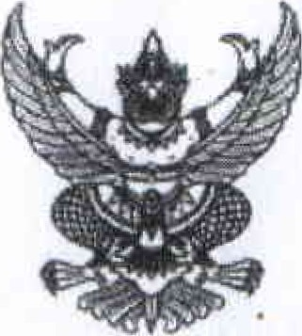

thyrnm oomtnaqhoaltnaunonq



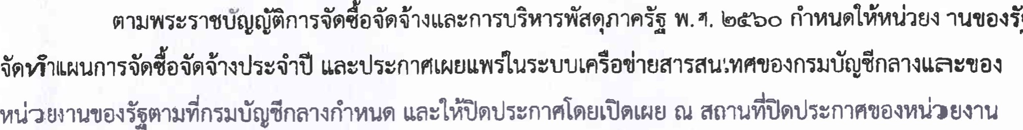

a

fiwun1iMthtJ<

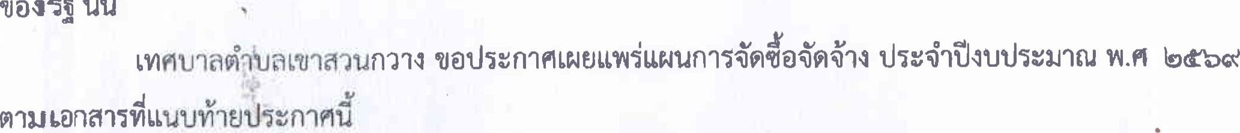

tru

I-hymn €u dud G)

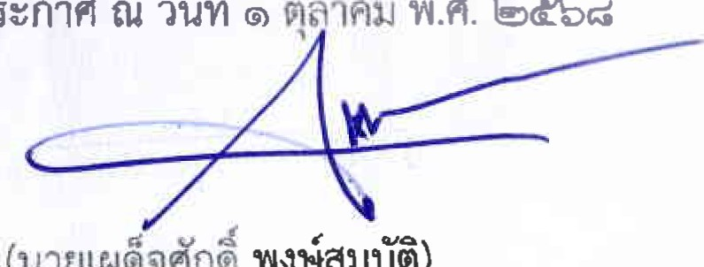

"M.

Udbd

(untJINhfYni

YR\*i.Jtjö)



