am mew



一

68089516462

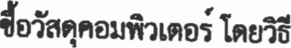

6 8·00

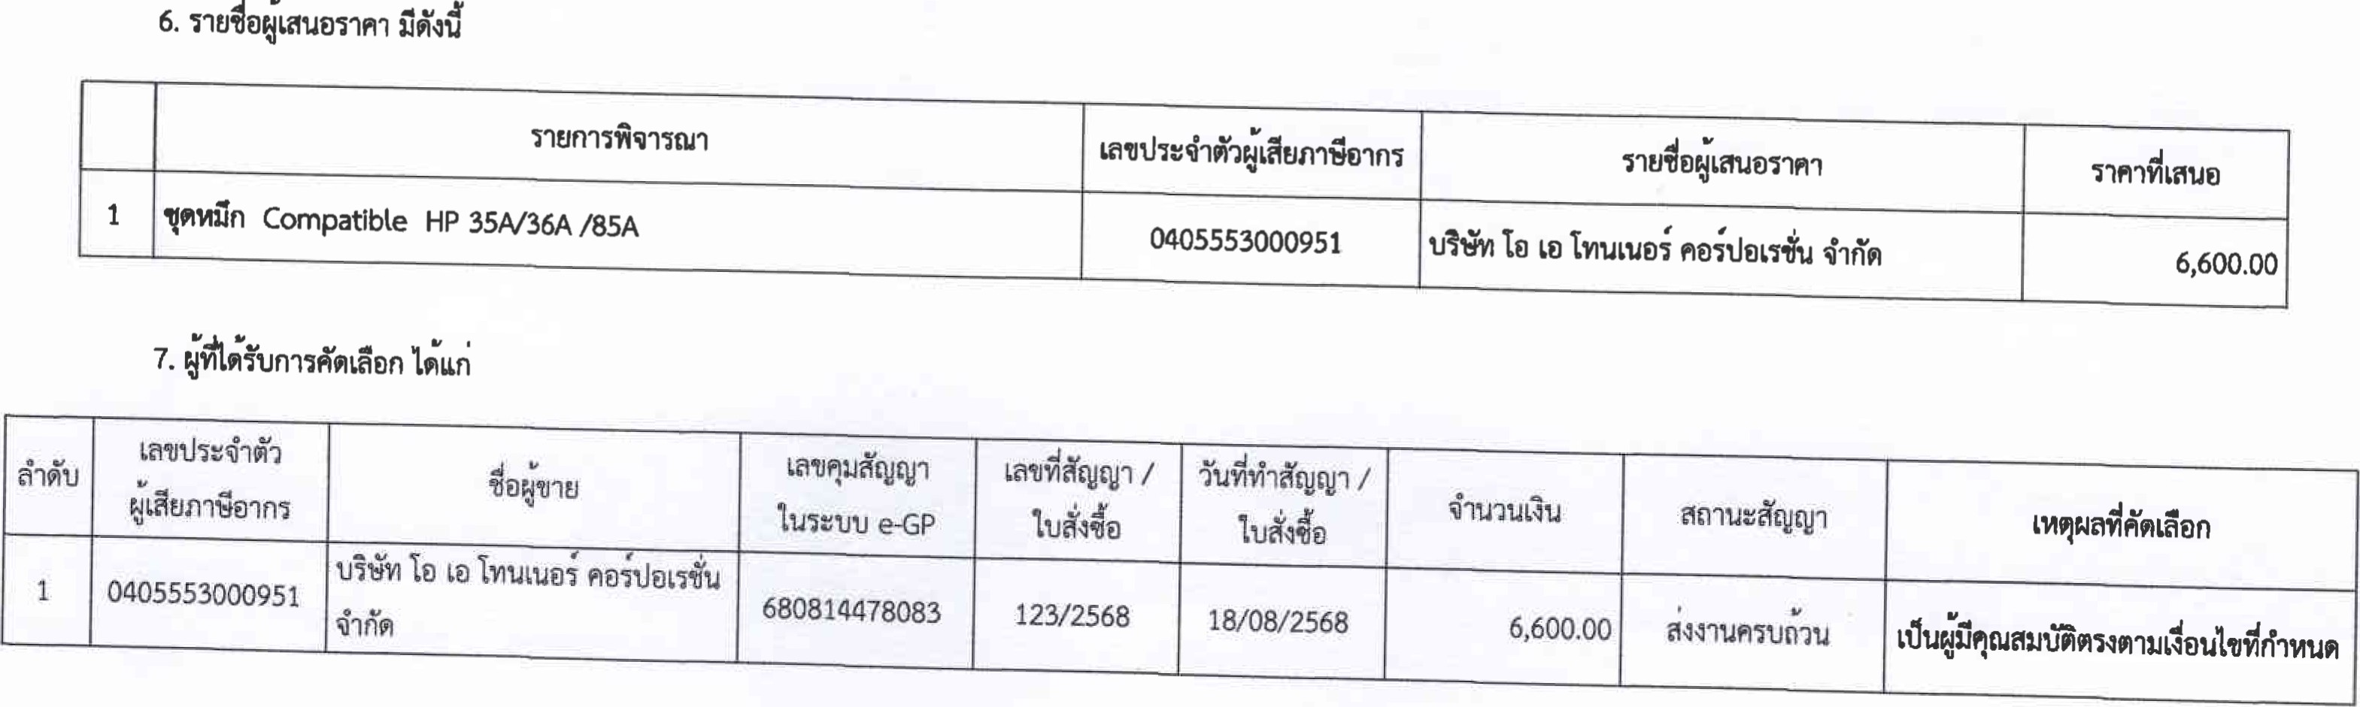

6

、

68

·

00

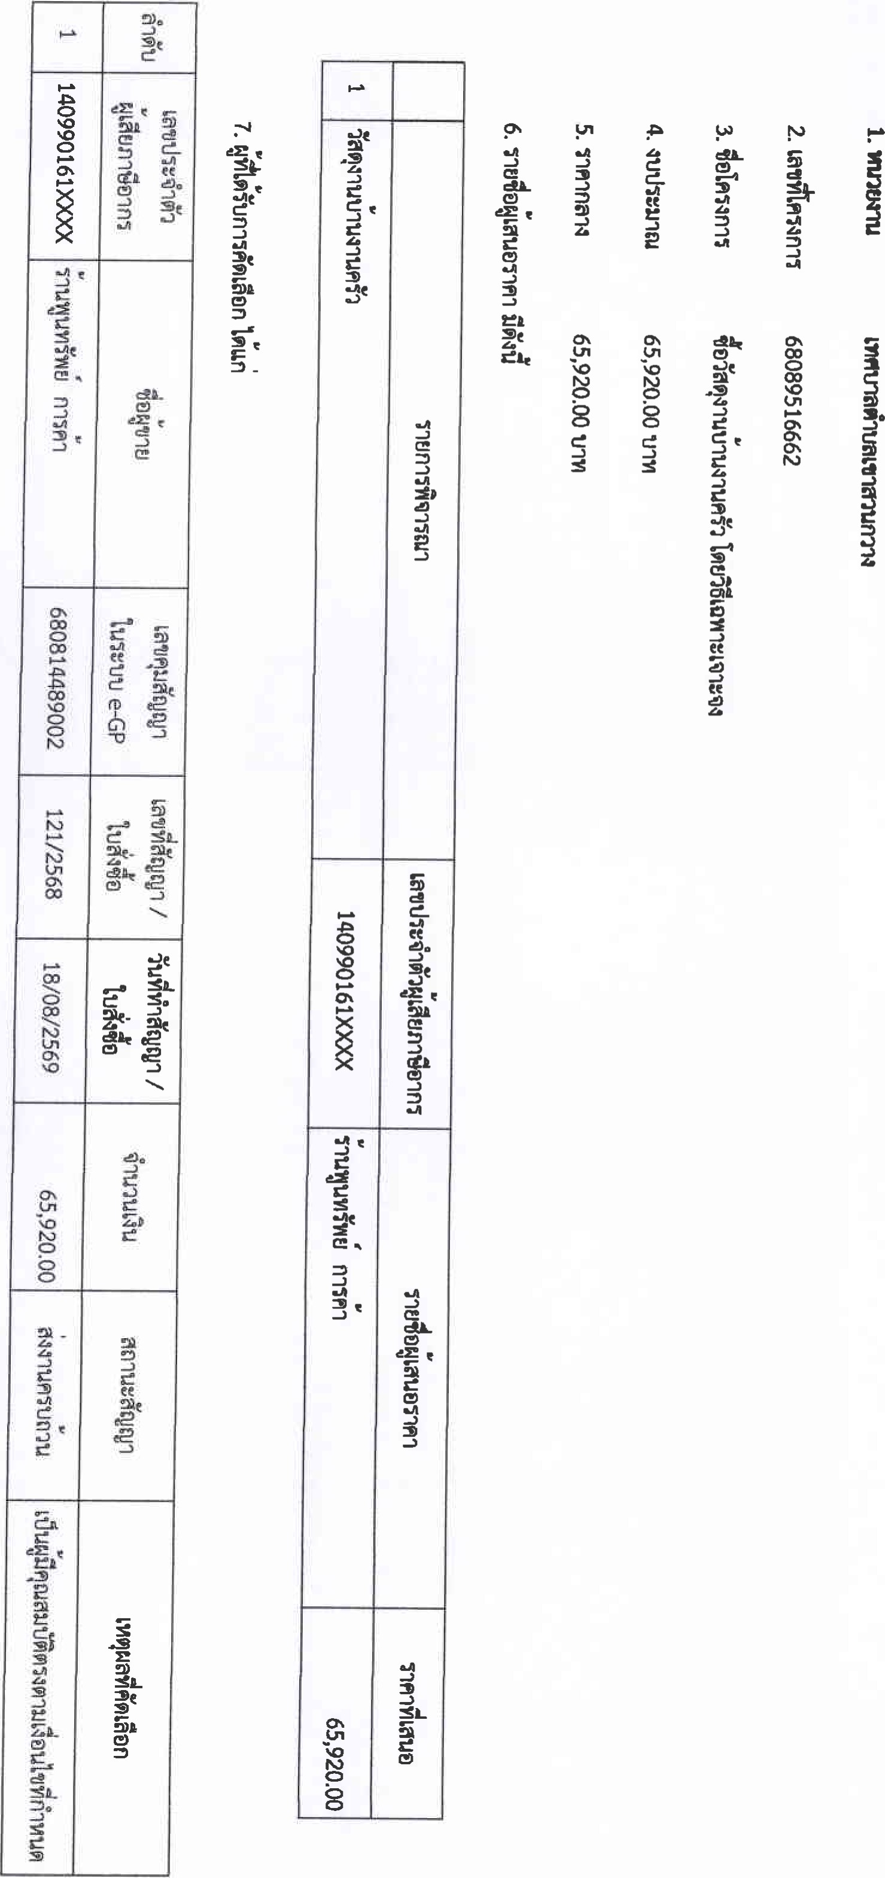

|  |  |  |  |  |  |  |  |  |  |  |  |  |  |  |  |  |  |  |  |
| --- | --- | --- | --- | --- | --- | --- | --- | --- | --- | --- | --- | --- | --- | --- | --- | --- | --- | --- | --- |
| |  |  | | --- | --- | |  |  | |  |  | |  |  | | 0 | 05 42 | |  |  | |  |  | |  |  | |  |  | |  |  | |  |

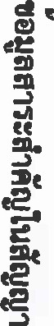



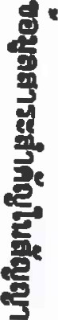68089516365

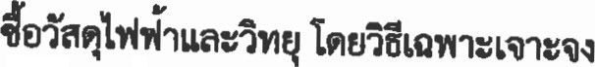

17-810·8

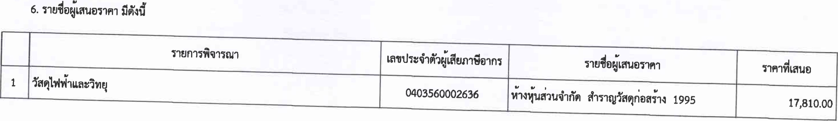

17

·

810

·

8

7

·

m

n

」

an

on

一

n

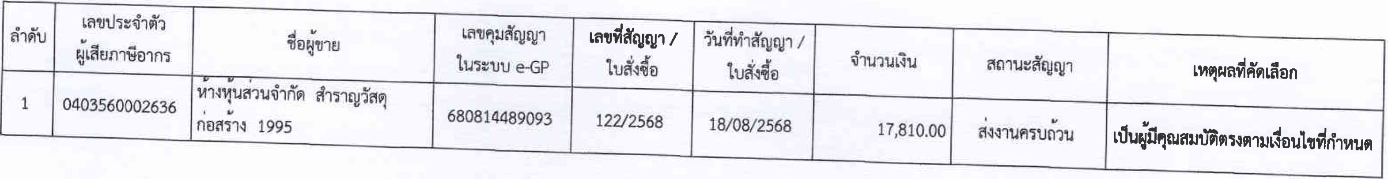

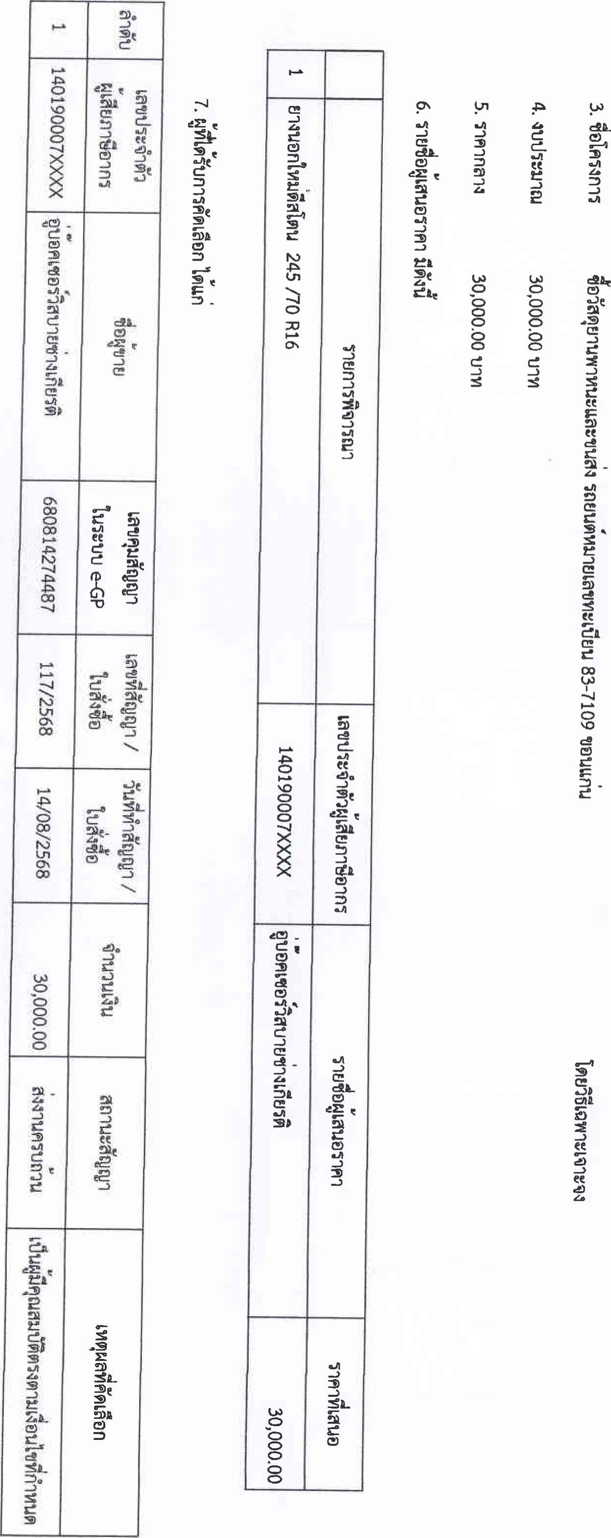

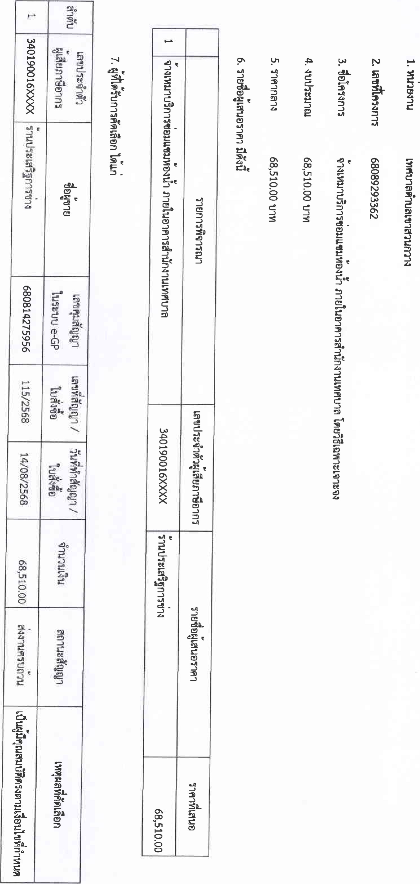

1. 一"tna 1332

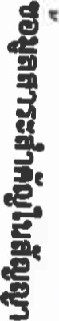  68089305975



4·•utJ 32 6112·8t.nm

6·112·00tJ')Yl



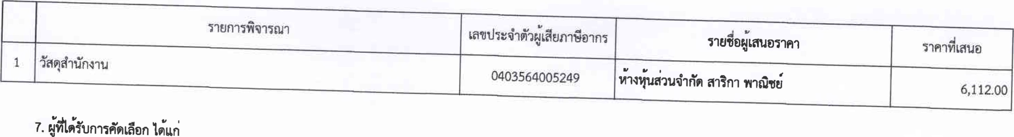

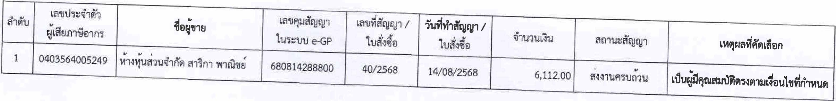

|  |  |  |  |  |  |  |  |  |  |  |  |  |  |  |  |  |  |  |  |
| --- | --- | --- | --- | --- | --- | --- | --- | --- | --- | --- | --- | --- | --- | --- | --- | --- | --- | --- | --- |
| |  |  | | --- | --- | |  |  | |  | ег е | |  |  | |  |  | |  | SL | |  |  | |  |  | |  |  | |  |  | |  |

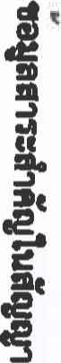





# 68089293373

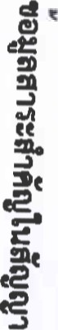 《 邑 ぷ00」0」( ョ、=00d000 =「」一=ョ000ョ00「 0=300ョ=、」00 0【 3=00ッ【-000 一ョ===ョ===《=ゴ《0= ~〔0~ 瑩PIご ご2己辷コ222 3にn22 っ己@辷コに(に 數0一7a《ゞつだ2568) U53も ち0 《



## 19し0P8tJ')Yl



|  |  |  |  |  |
| --- | --- | --- | --- | --- |
|  | 1 | |  | |
| 340990049XXXX | |  | |
| コUさ | |  | |
| 68081 73231 | | ざ ビ e-GP | |
| 116、2568 | |  | |
|  | 13708、2568 | |  |  |
| 190P00 | |  | |
| 2 っ団につ2心 | | aョ 当 | |
|  | |  | |

19,58.8

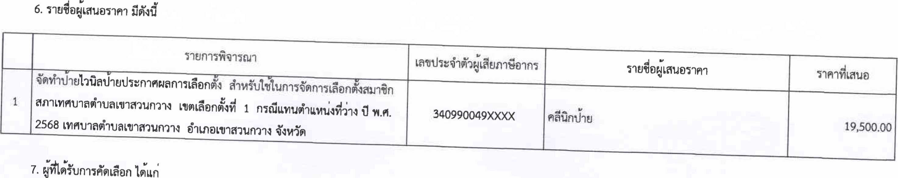



68089172787

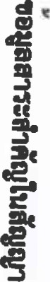3. 

22b50·00t.j-m

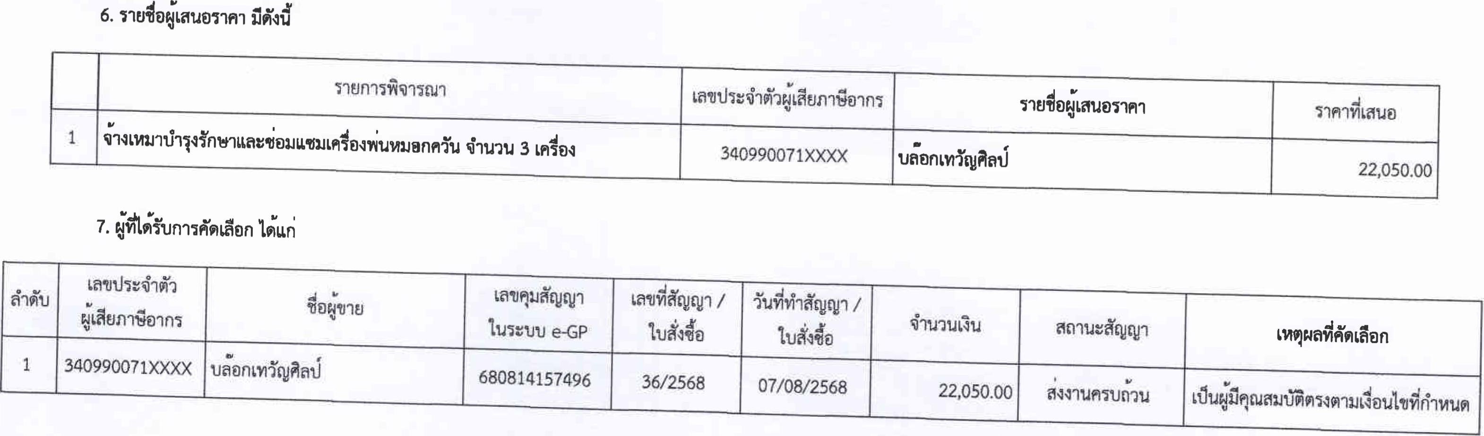

22-050b0

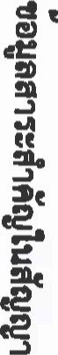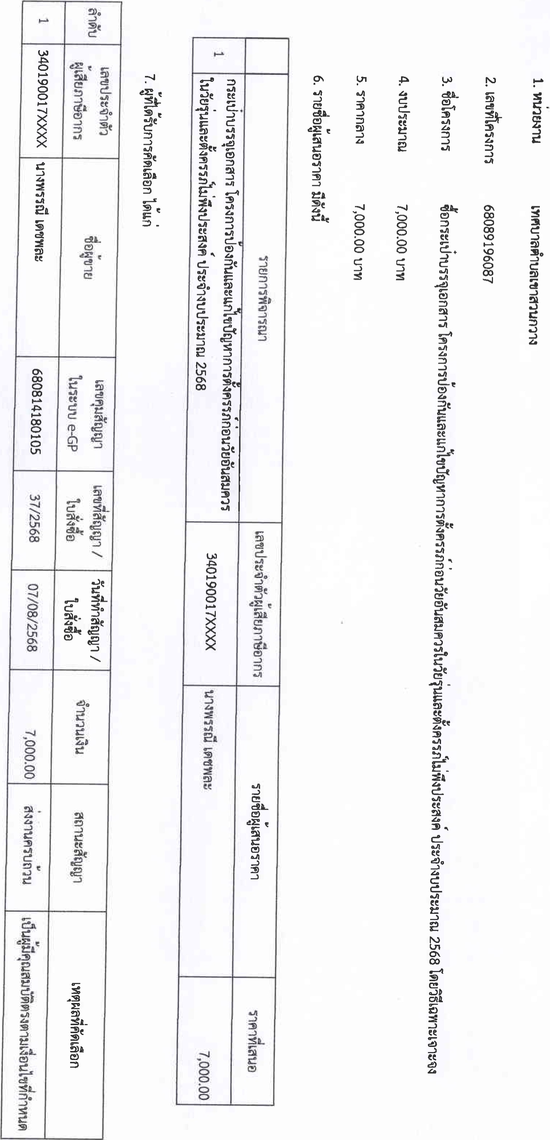

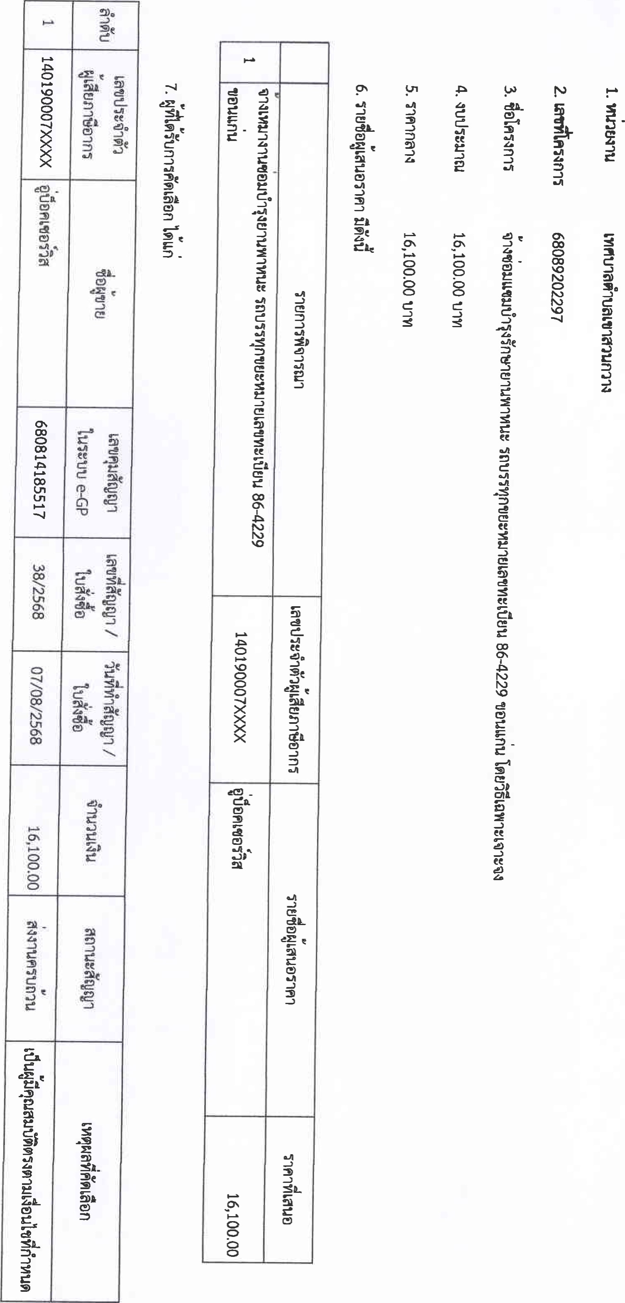

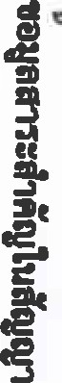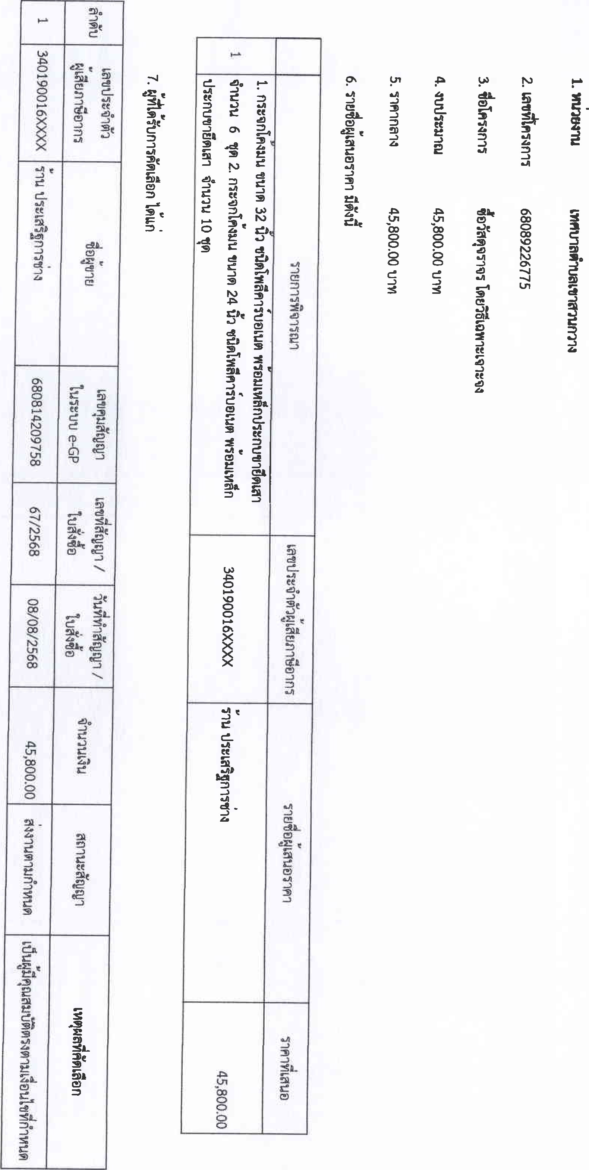

## 틓 .F 鷲 를

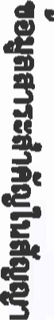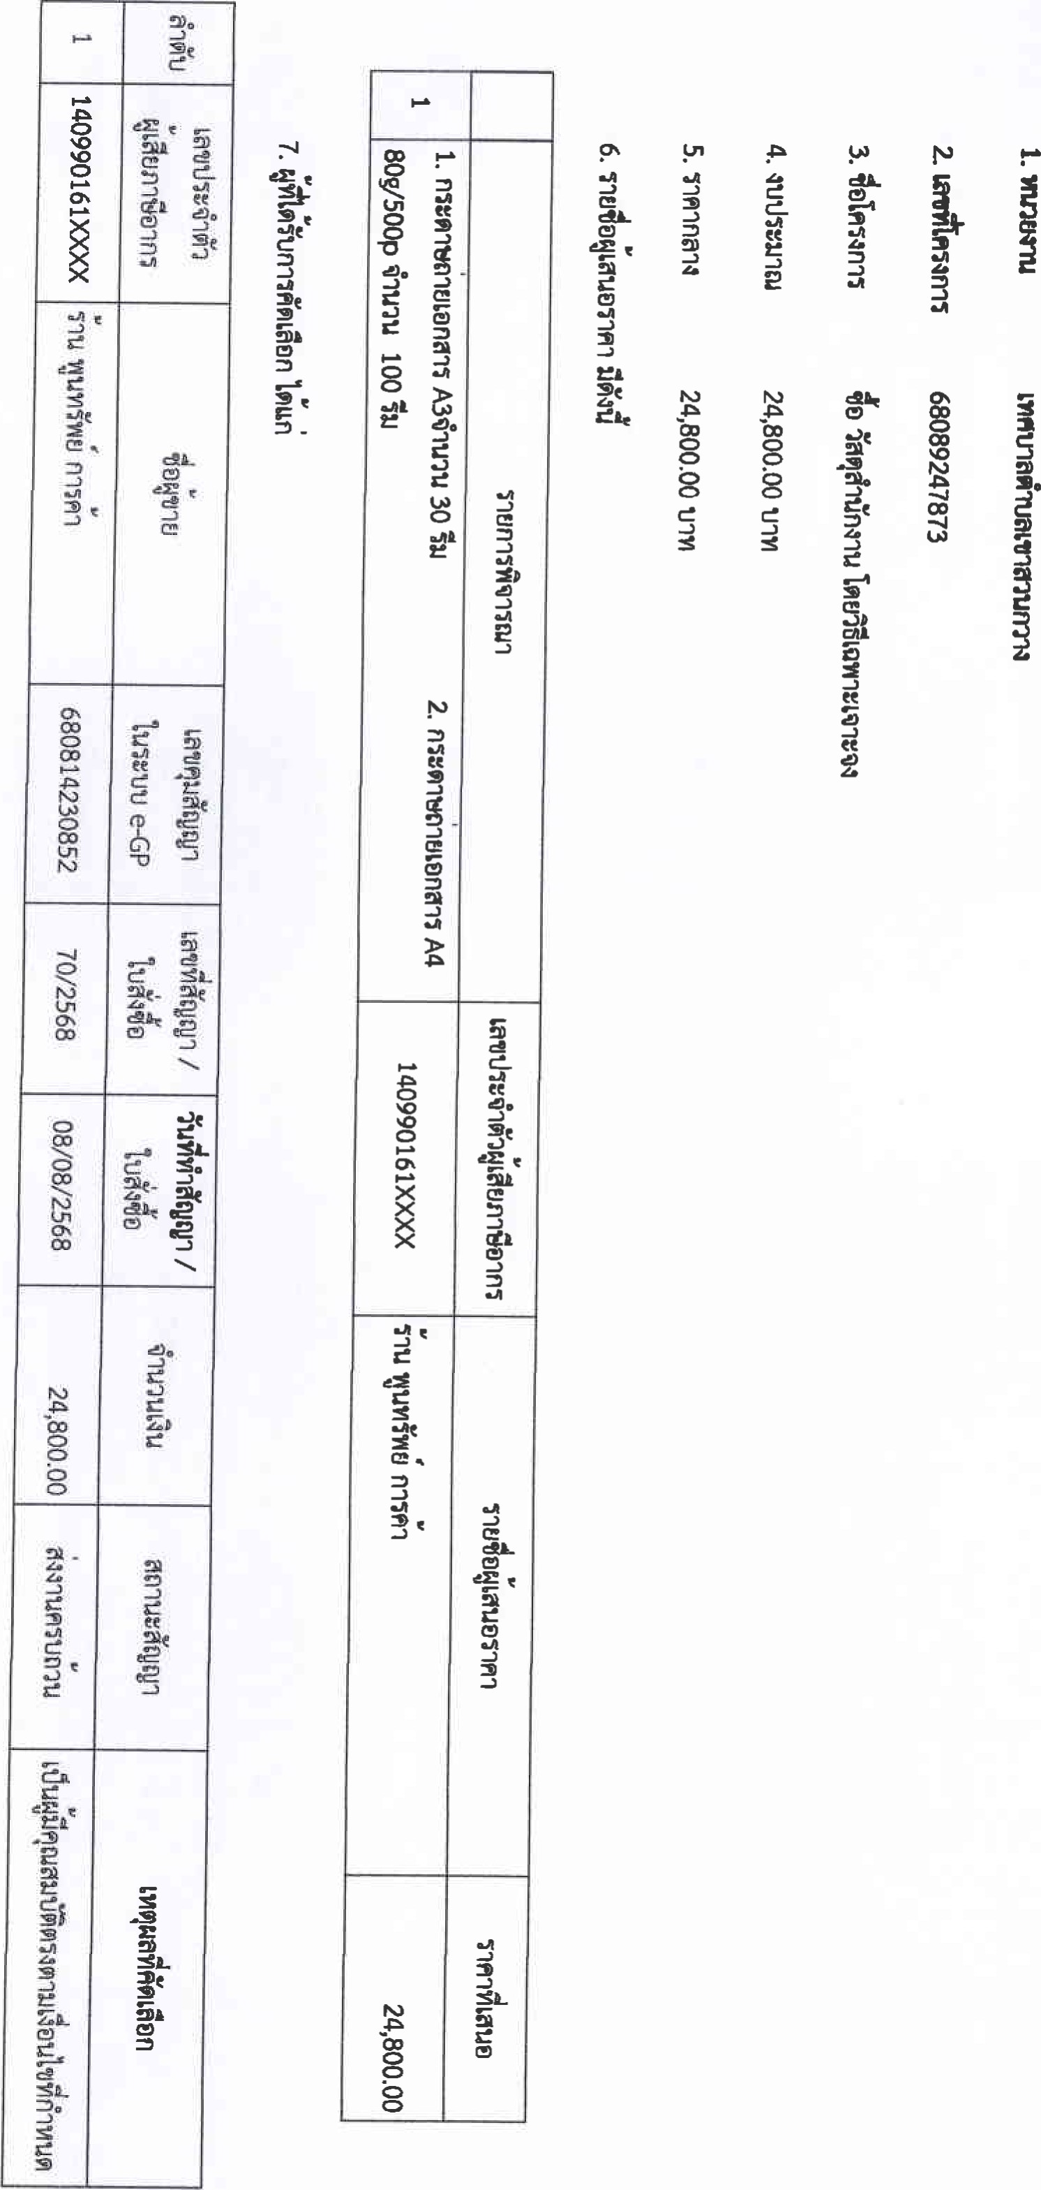

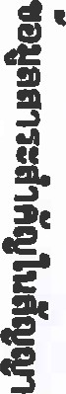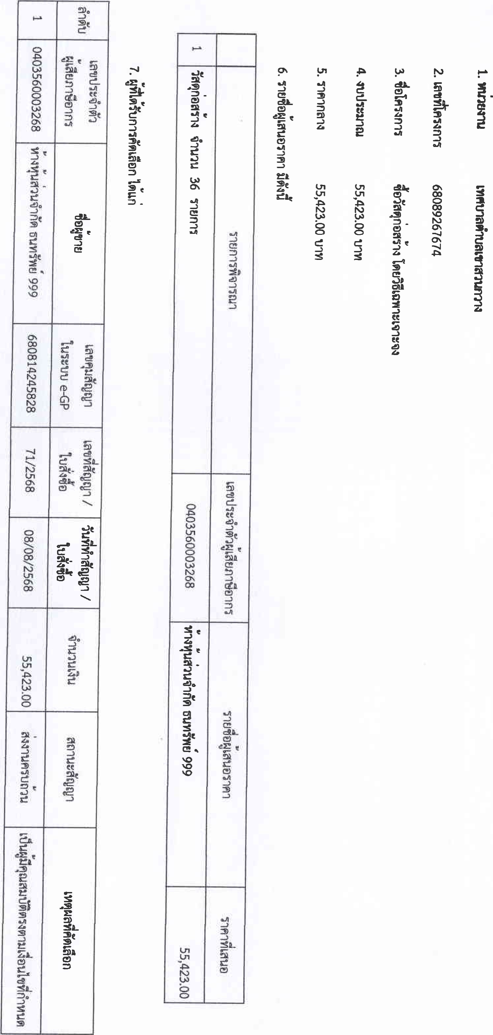



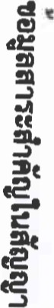68089286495



5、000·00

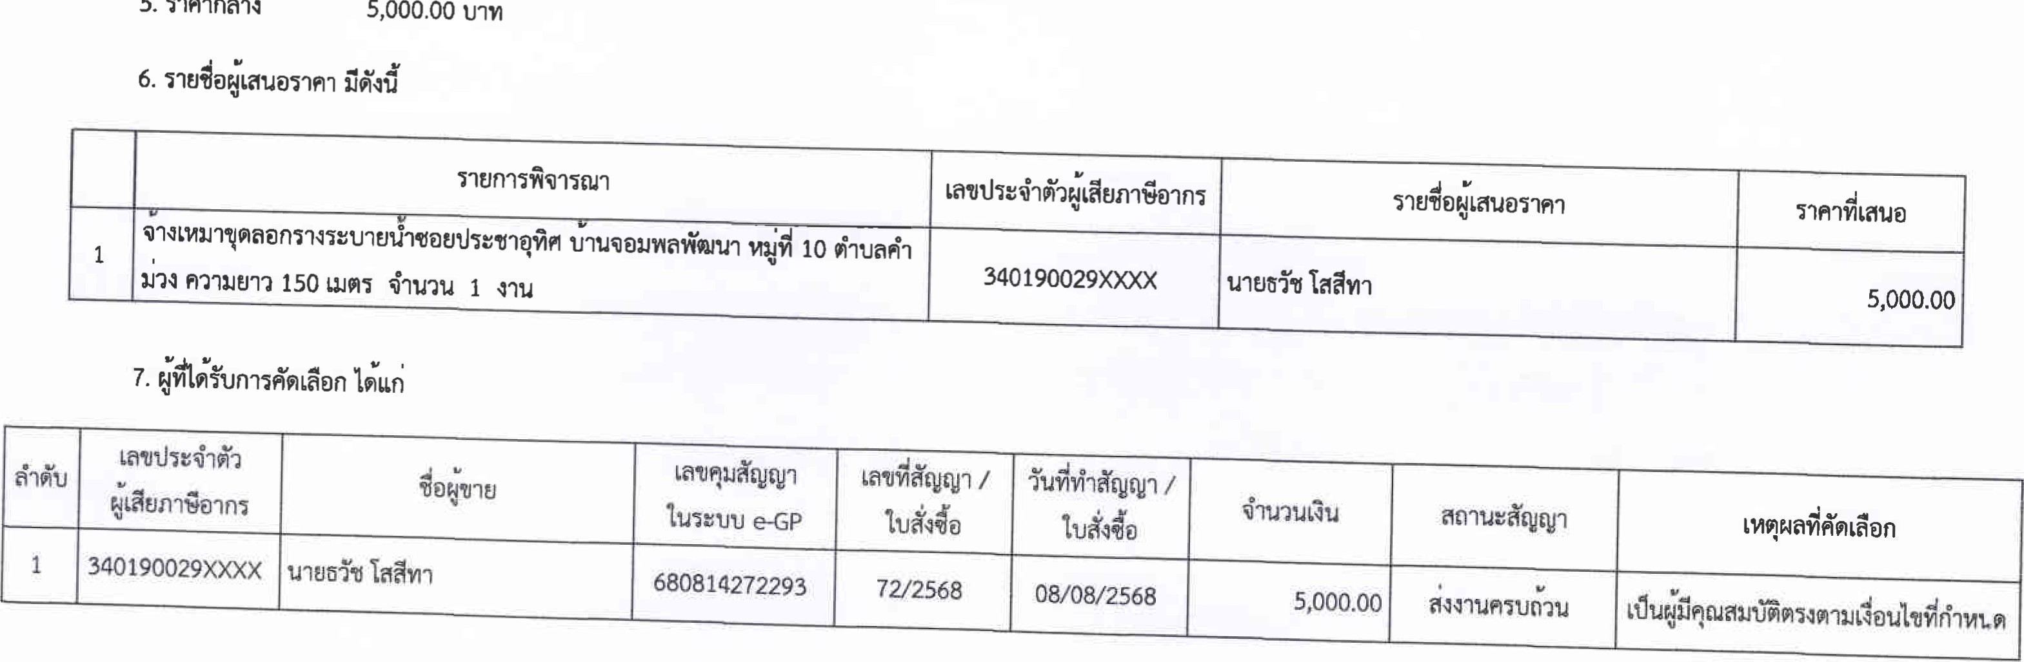

1.435 

# ド気 68089131750

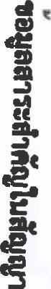 3.《ョに000・=0《000=、=00一0-0E0=- 00一0・0==0に一0030 《

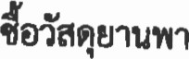

0

0

00

=



8.40P00三

|  |  |  |  |  |  |  |  |  |  |  |  |
| --- | --- | --- | --- | --- | --- | --- | --- | --- | --- | --- | --- |
|  | | 4 | |  | | 2 | | 1 | |  | |
| ョに亠コに | |  | | n回2ム三 ュp「0t0コ | | コ働ム553なp「0t0コ | | ゴFJコ 鰤コ切23 | |
| 140190007XXXX | | 140190007XXXX | | 140190007XXXX | | 14日90007XXXX | |  | |
|  | |  | |  | |  | |  |  |
|  | 1、500.8 | | 80P00 | | 3る0P8 | | 3一10P00 | |  | |

340P85



|  |  |
| --- | --- |
|  |  |
| 8 |  |
|  |  |
|  |  |
|  |  |
|  |  |
|  |  |
|  |  |
|  |  |



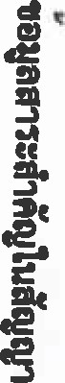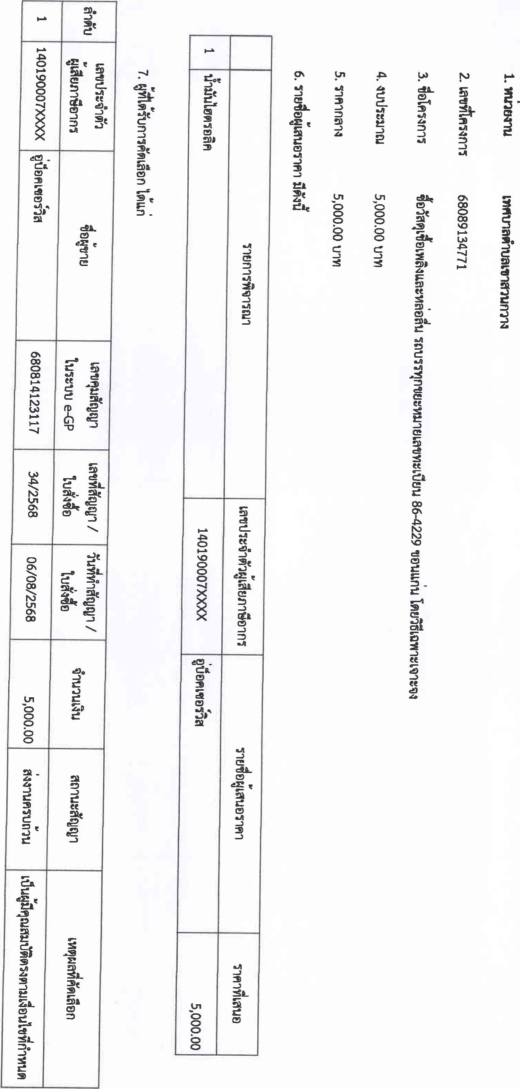

|  |  |  |  |  |
| --- | --- | --- | --- | --- |
|  |  |  |  |  |
|  |  |  |  |  |
|  |  |  |  |  |
|  |  |  |  |  |
| MINI | | | | |

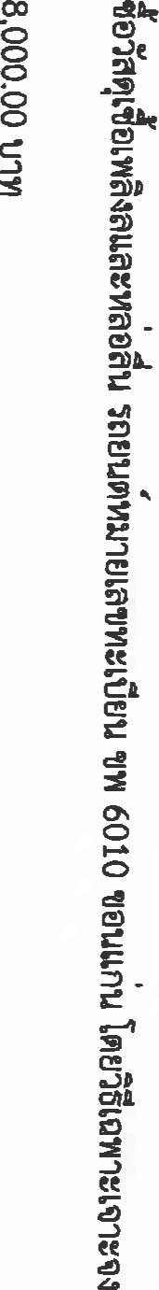 0

|  |  |
| --- | --- |
|  |  |
| 0 | 4厹 |
|  |  |
|  |  |
|  |  |
|  |  |
|  |  |
|  |  |
|  |  |



